2.5 The Precise Definition of a Limit

The definition of a limit presented in section 2.2 is vague…too vague. What do the following phrases mean?:
“x is close to 1” “make the values of arbitrarily close to L”

We wish to add some rigor and exactitude to these types of statements.

General Idea:
How could we show that ?

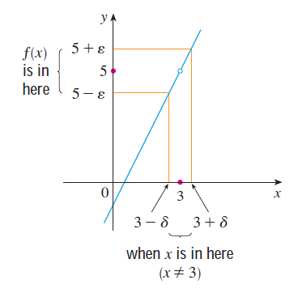
Notice that in the picture at the right we measure closeness using two different Greek letters:

- (delta) is used to measure

- (epsilon) is used to measure

We now develop the following rigorous definition.

Definition: Let be a function defined on some open interval that contains the number a, except possibly a itself. Then we say that the limit of f(x) as x approaches a is L, and we write when the following holds:

Note: Determine the interval communicated by each of the following absolute value inequalities.

Using this knowledge we could rewrite the intervals in the previous definition in the following way.

Definition: Let be a function defined on some open interval that contains the number a, except possibly a itself. Then we say that the limit of f(x) as x approaches a is L, and we write when the following holds:

Note: Writing our intervals using absolute value inequalities will actually make it easier to verify the value of a limit.

Example 1: Consider the motivating example where we looked at . Suppose that someone challenged you to show that the y-values of the function can get with 2 units from 5. Determine a value of that would make this possible.

Example 2: Prove that using only the definition of limit.

Example 3: Prove that using only the definition of limit.

Note: See section 2.5 of the textbook for more examples of an epsilon-delta proofs.

Note: There are similar rigorous epsilon delta definitions for one sided limits. We now present the rigorous definition of an infinite limit (we present , is similar).

Definition: Let be a function defined on some open interval that contains the number a, except possibly a itself. Then, we write when the following holds:

For every number there is a number such that if , then .

Note: If time permits, the instructor will explore the example of and show how it intuitively relates to the definition above.

Note: We can easily adjust the definition of above to define by requiring that .

